**Major Issues faced during AWS Assignment**

1. **Remote desktop not getting connected and showing below screen as error.**

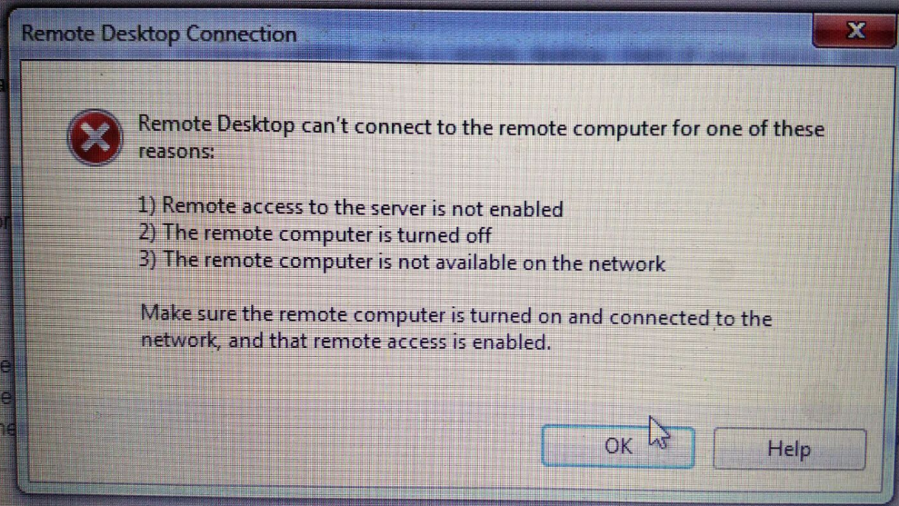

**Solution:**

Usually due to the Security group settings, one might face this issue. The destination is your Security group settings define the traffic that is allowed to access the Remote Desktop. Due to firewall settings, even when you have defined your own IP address, Remote Desktop Connection might not work.

To avoid this, make sure you change the “Destination” in RDP settings for your Security Group rules from you IP address to the one given below:

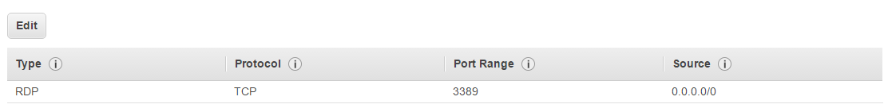

1. **Connecting to RDS instance**

Some students have faced issue with connecting to RDS and have got error as given below.

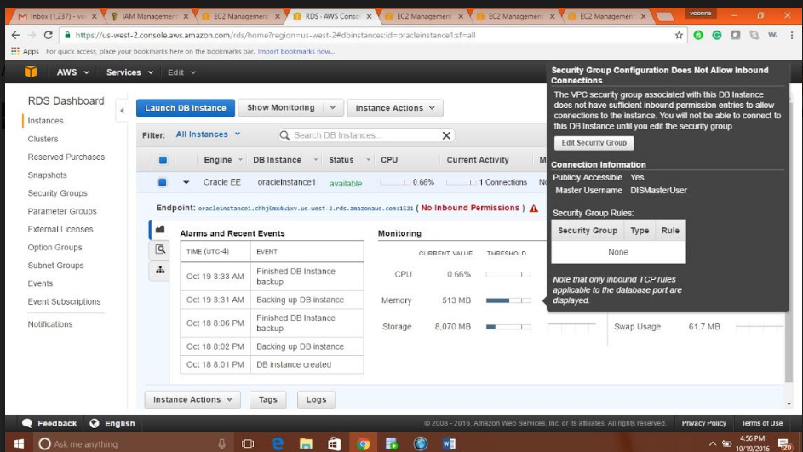

This error is because you have not defined the security group in the way mentioned in the tutorial. Separate security group is to be used for Windows Instance and DB instance.  
  
Solution: Use the security group with below mentioned rules

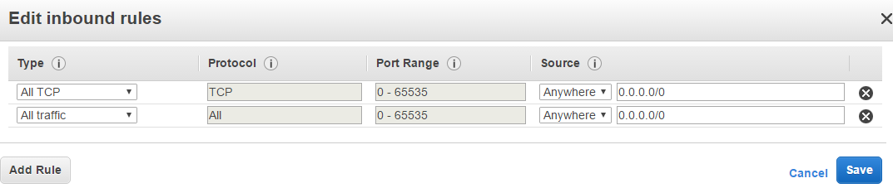

**Outbound Rules**

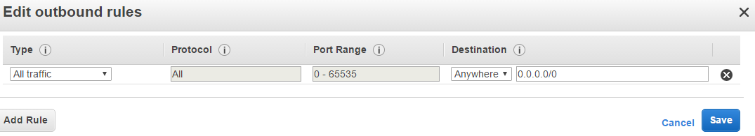

1. **Moving files between local machine and windows instance**

One can easily copy the files from local machine and windows instance. One has to use the traditional method of copying i.e. Ctrl+C.

1. **Error while downloading JDK on the windows instance**

Before starting to download the jdk, check if cookies and javascripts are enabled in the Internet explorer. Once these pre-requisites are completed, start proceeding on with the download.